
Understanding the World
- Thinking about who is in my class and school. Thinking about my school building.
- Identifying members of my own family, friends and special people.
- Discussing past and present experiences in my own life.
- Finding out about special family celebrations and customs.
- Finding out about the celebrations of Diwali, Christmas and Hanukkah and why these festivals are important to certain people.
- Remembrance.
- Exploring seasonal changes.

Portishead Primary School
EYFS Term 1 and 2: Let’s Celebrate

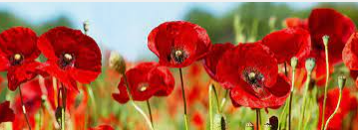
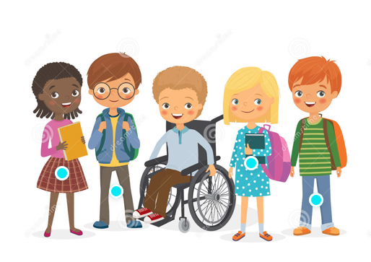
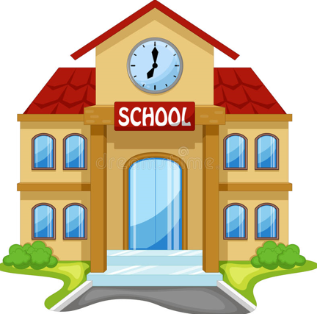
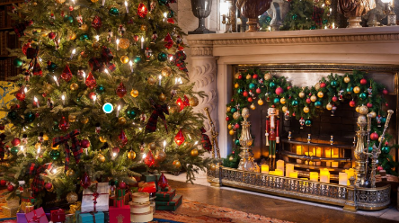
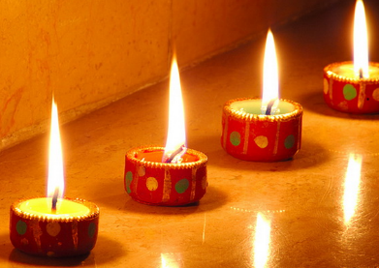
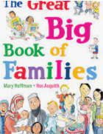
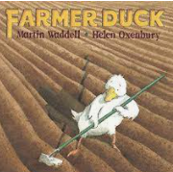
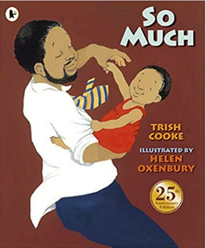
Remembrance
What is Remembrance? Who and what are we remembering? Why is it important to remember and respect others?
Celebrations
Celebrations that are special to me and my family. Christmas, Diwali and Hanukkah.

Special People
Who is in my family? Who are my friends? Which people are special to me? Why are they special?
My School
Who is in my class and school? What are our school and class rules? What do we learn at school? What is in my school building?

Physical Development
- Pincer grip, pencil grip, handwriting patterns and letter formation.
- Exploring tools, large and small apparatus.
- Thinking about myself and how I can manage my own needs in the classroom.
- Thinking about my own physical space and ways of moving in my space.
- Manipulating and controlling small apparatus.
Personal, Social and Emotional Development
- To listen carefully to the experiences and ideas of others.
- To begin to think about how our experiences are different or the same as others.
- To begin to develop and build upon relationships within our school and class.
- To understand and follow rules.
- To understand why we are all special.

Key Texts

Literacy
- Phase1 and 2 phonic activities.
- Guided reading activities.
- Understanding key concepts of print.
- Sequencing and innovating stories.
- Discussing key characters.
- Name writing.
Communication, Language and Literacy
- Describing our experiences by organising and sequencing our ideas.
- Understanding, asking and answering questions.
- Engaging in story times, building familiarity with new texts and asking and answering questions.
- Performing familiar stories.
Mathematics
- Matching and sorting.
- Making comparisons.
- Exploring pattern.
- Composition of numbers to 5.
- Shape and spatial awareness.
- One more and one less.
- Time.
Expressive arts and design
- Using a variety of media to create self-portraits.
- Making decorations.
- Using clay to create lamps.
- Role play – familiar experiences and roles.
- Learning, singing and performing repetitive songs and rhymes.
- Using percussion to change sounds, listen carefully and stop on a signal.

Portishead Primary School
EYFS Term 1 and 2: Let’s Celebrate

