

Eco Club Termly Newsletter

Autumn Term 2021

Brilliant biodiversity!
Eco Club and Forest school have been working hard to increase the biodiversity of the school site. We have installed a mini pond, more planting and a wormery. We hope to be able to compost our fruit waste and turn it into compost to use in our planters. School has now installed a low fence along the Marina side of the site which we will develop into a wildlife corridor – essential joining spaces that allow wildlife to move around built up areas.

If you have any plants you are willing to donate - ideally herbs or native flowering plants - please drop them to the school office.
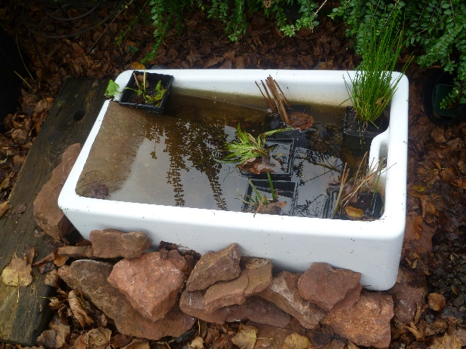
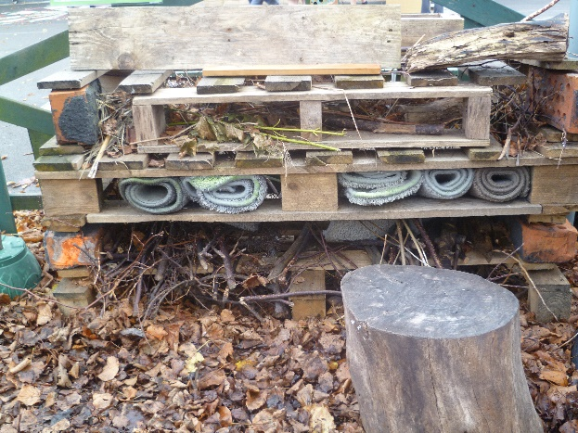

Our bug hotel gets filled with natural materials to attract insects. We are making it a living roof.

Our new mini pond will attract insects and hopefully frogs.

We want less waste – focus on food
Eco club were interested in how much waste we create through our lunches at school. Our catering company, Aspens, has already set up online ordering so they know exactly how many meals are wanted to help reduce the amount of food wasted every day.
Eco club were also interested in the material rubbish produced from our packed lunches. They collected the rubbish from packed lunches during the first four day week of term and are planning a project aimed at encouraging parents to put in less single use plastic and give some hints and tips on how to go packaging free in lunch boxes. Here is the rubbish we collected from lunch boxes:
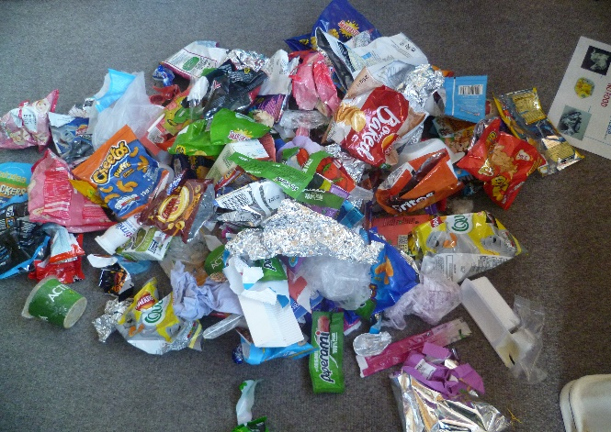
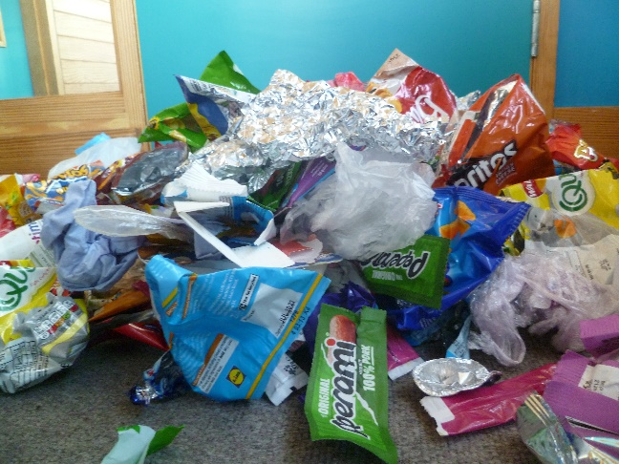

Eco Club want to encourage you to…
Change one thing!
Buy large packs of dried fruit, crisps or biscuits and put a small handful in each day
Use a sectioned lunchbox so that not everything needs to be wrapped
Use sustainable wrapping or reuse foil wrapping over and over again
Bake small cakes or biscuits to use in lunchboxes instead of wrapped items

Some great examples from around the school
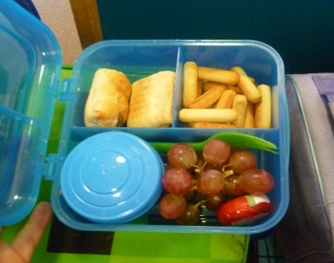
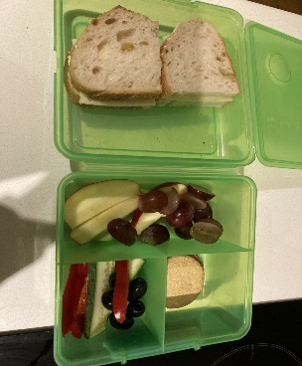
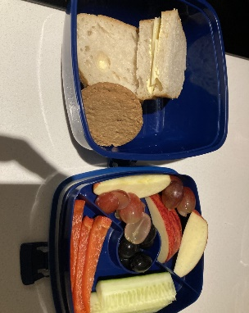
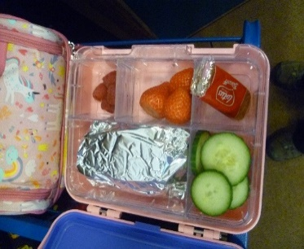

A word from Eco6
Eco 6 is our year 6 Eco club that support our whole school Eco Club run my Mr Taylor with interested children from Year 6. Here is a word about what they are doing this term from one of their members:
Eco6 are a small group of Year 6s who are passionate about the environment and want to make the school greener and a better place for wildlife.
Currently we are encouraging teachers to change the food that they eat so that they have a smaller impact on the climate. This might involve eating less red meat or even stopping eating any meat at all! We have surveyed them to see what their current habits are and will run an assembly and campaign asking them to Change One Thing.
Next, Eco6 hope to discourage teachers from leaving lights and electrical boards on and using up too much energy.
Joel Y6
Christmas Eco tips and tricks from Eco Club
Use recyclable wrapping paper or decorate the boxes the gifts were delivered in.
Think carefully about how much food you need over the holidays – and what to do with the leftovers.
Shop locally, walk down the high street and see what you can find for Christmas presents.

We have two local specifically ethical shops on the high street which work hard to make shopping greener. Consider supporting them if you can.



