PP Strategy and impact 2018/19

Intent:
RAPP 4.2: Improve pupil outcomes to secure excellence
Evidence for action:
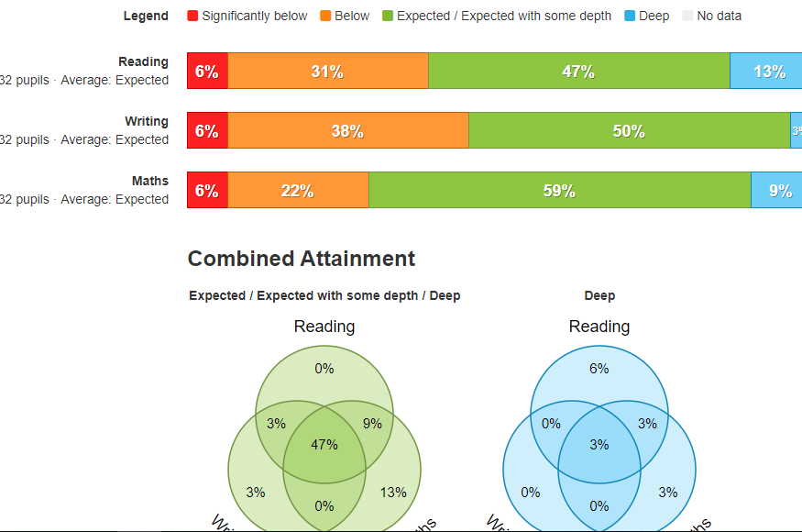
Many of the pupils that are disadvantaged are on the SEND register. There are also additional pupils across the school that are not on the SEND register but lack confidence in their own ability.
Many of the disadvantaged pupils require support from outside agencies, the school works with available support for both city and county residents. This includes Speech & Language, Educational Psychology and Counsellors
Gaps in learning being identified both socially and academically.
Some of our families due to ill health or other external factors face challenges with adopting consistent routines with pupils being able to focus on their schooling. % of disadvantaged pupils have been affected by external factors which impact on their school life. These families receive support from our Inclusion leader, learning mentor, mindfulness coach and office staff.
Many of our disadvantaged children receive very little or no support with reading at home or completing homework at home. Some have no routines regarding healthy eating or general appearance.
Some of our disadvantaged pupils have low attendance. This is contributing to lower than expected academic progress. This is a minority of families and school are working closely with the families to increase the attendance.
Actions:
Headteacher, Inclusion leader and attendance manager have worked to support families where children’s attendance is having an impact on progress.
Children access afterschool clubs, trips and overnight residential trips.
All PP offered free breakfast club- 25 mins childcare and free breakfast.
All PP children offered milk and fruit at breaktime.
Funds for additional resources needed such as talking tins to aid PP children etc
Budget available to allocate book bags, uniform, school shoes/ any other necessary equipment.
Work with parents to improve relationships between school and home and offer/ refer to early help.
Friendship Fridays discussing values and providing time for mindfulness.
CLA/ PLAC teacher to provide social and emotional and academic interventions
Targeted SEMH interventions for identified students. A mindfulness coach provides sessions for targeted pupils.
School nurse referrals
1:1 tuition and small group intervention planned and delivered by teaching staff, PP teachers and SENCO. Ever 6 teacher - delivers interventions in the am to KS1 and KS2 for Reading, Writing and maths catch up
Trip contributions (especially towards Year 6 and Year 4 camps)
Encouraging all staff to recognise independent learners and develop a can do it attitude for all disadvantaged pupils by encouraging independence and incorporating challenge into all lessons.

Impact:
Monitoring has shown that a few pupils are still not as resilient in learning as they could be. We have bought in an advisory teacher to support children in Year 1 transition into year 2 in order to encourage independence.
Three pupils who are PP have been assessed to unpick learning difficulties. They have been added to the SEND register.
70% of PP children have attended homework club this year (all of ks2 P children).
Paid £100 per year 6 for camp. Paid £85 for Year 4 camp.
All PP children have been invited to at least three sporting events in the year.
All PP children have attended forest school led by a forest school specialist at Gordano School.
8 children have moved from expected to greater depth.
3 children have gone from expected to below and in the spring data- we have analysed their gaps and changed the intervention for this term.
All PP children have access to additional reading slots in the week.
Mindfulness sessions are already providing impact within the classrooms. In Reception and Year 4 children are using mindfulness strategies when they feel ‘fizzy’.
25/31 parents attend the Spring PP meeting.
5 families have opted for free breakfast club.
9 children have free milk and fruit.
Disadvantaged children are making good progress overall- years 3,4,5 and in particular
Interventions are monitored and changed termly to show impact on the children

Next steps:
Encourage more children in KS2 to take up fruit, milk and breakfast
Ensure all parents attend transition meetings in the summer term
Add forest school to the Pupil premium budget for next year due to impact on children

