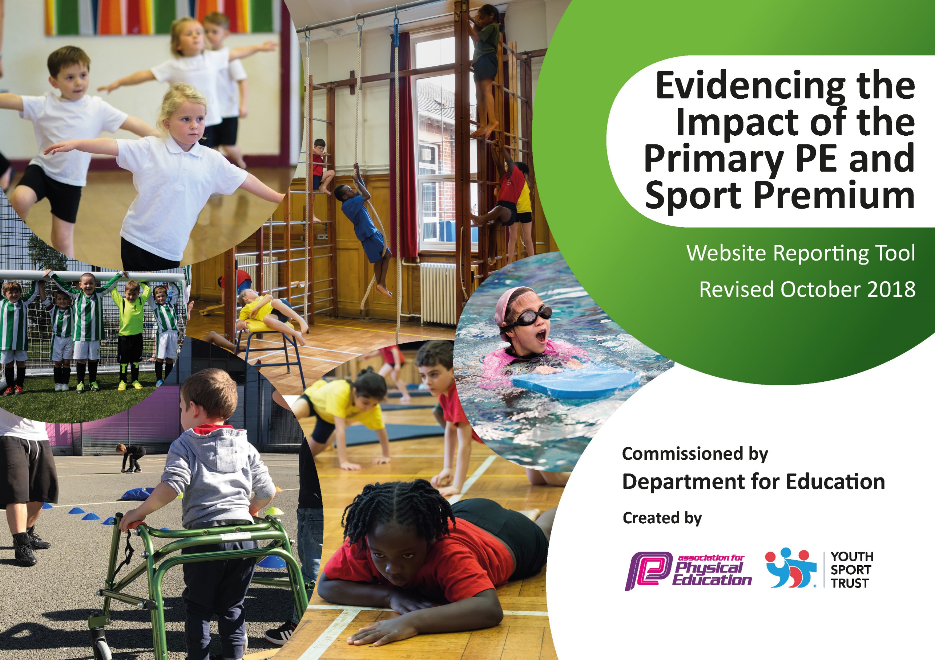
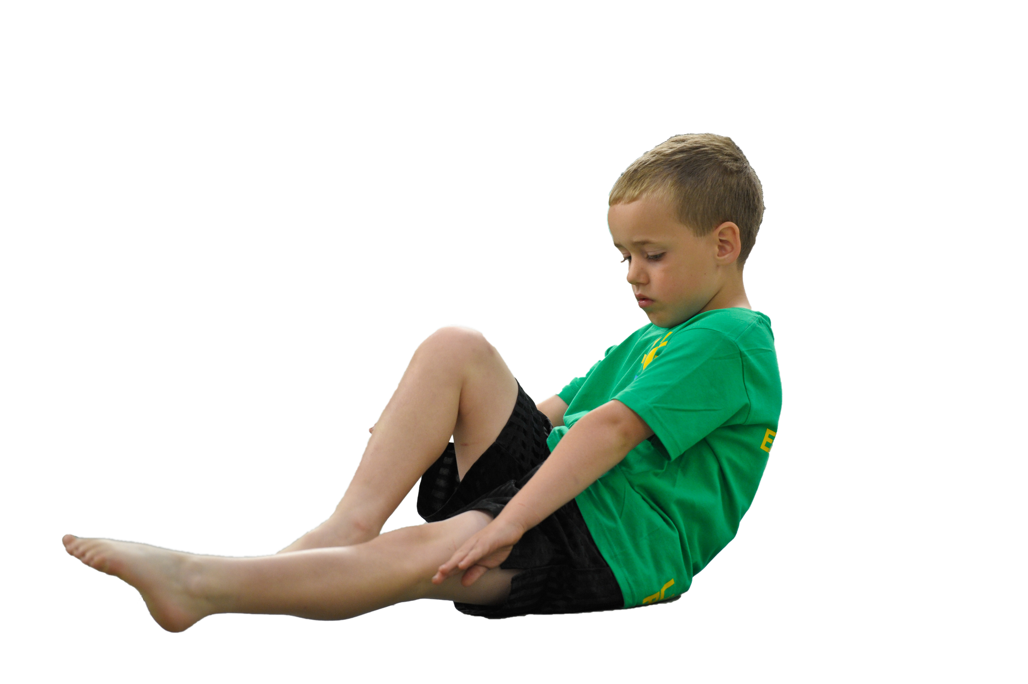
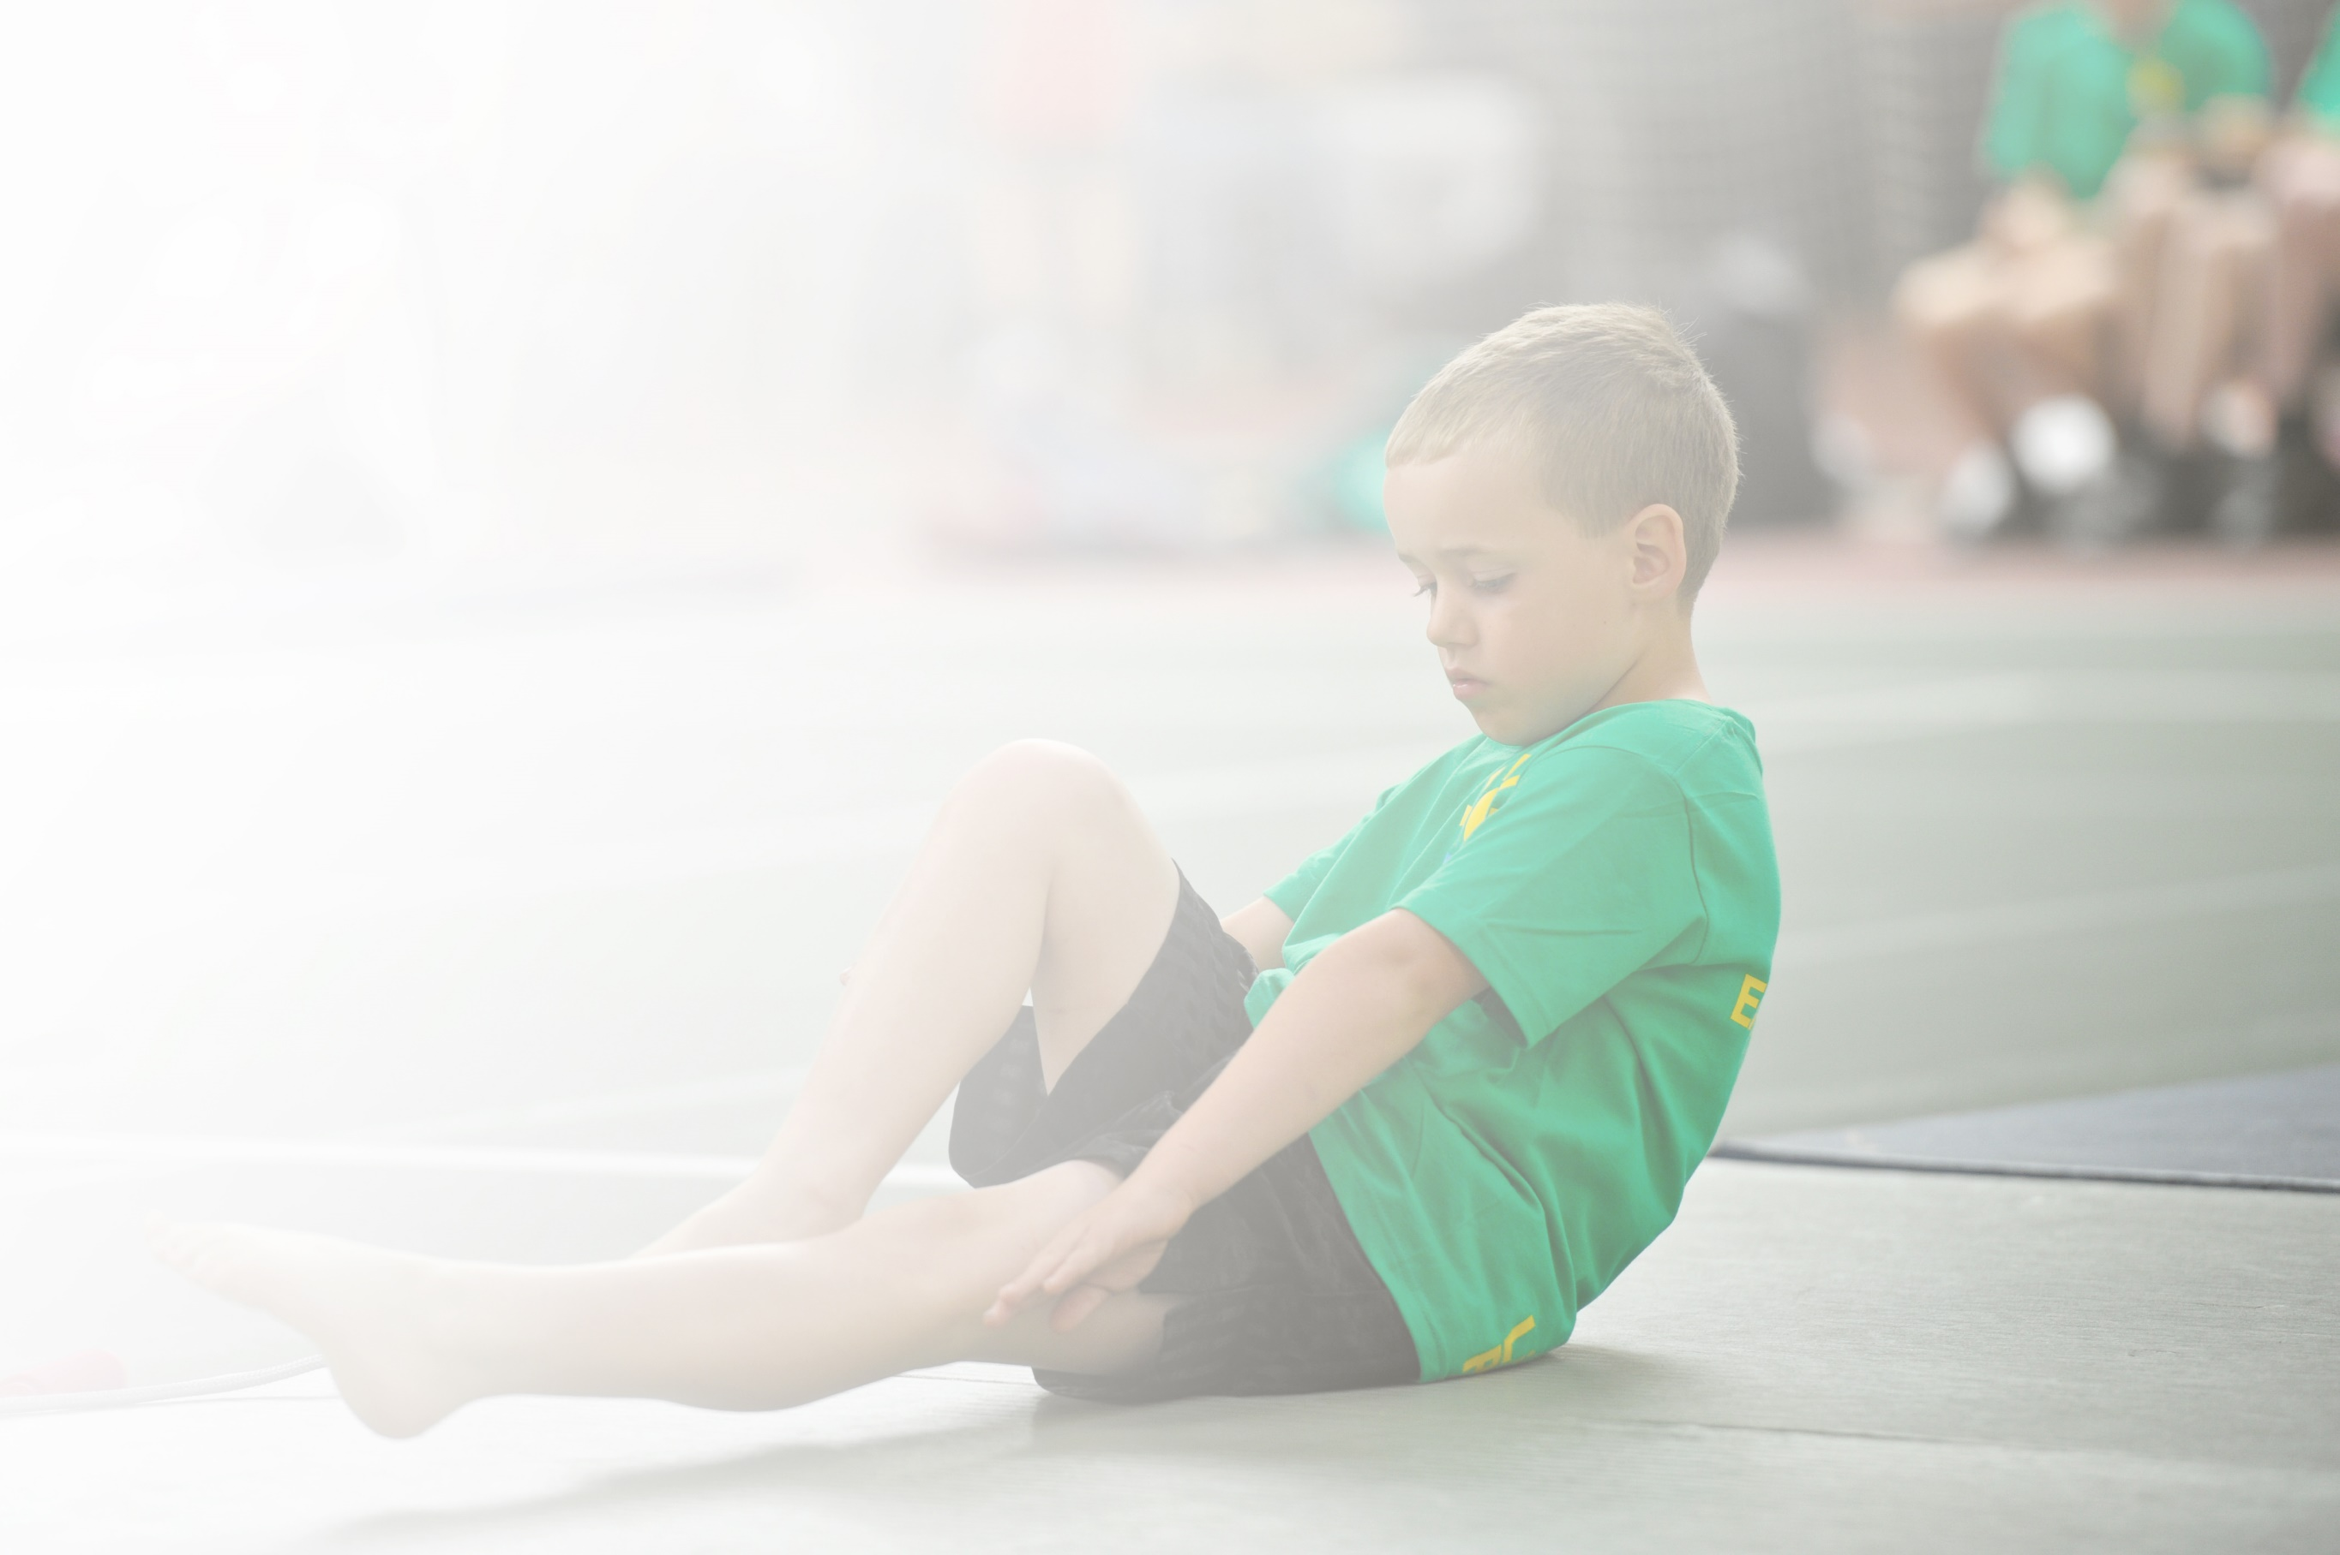
Schools must use the funding to make additional and sustainable improvements to the quality of Physical Education, Sport and Physical Activity (PESPA) they offer. This means that you should use the Primary PE and Sport Premium to:

- Develop or add to the PESPA activities that your school already offer
- Build capacity and capability within the school to ensure that improvements made now will benefit pupils joining the school in future years

Please visit gov.uk for the revised DfE guidance including the 5 key indicators across which schools should demonstrate an improvement. This document will help you to review your provision and to report
your spend. DfE encourages schools to use this template as an effective way of meeting the reporting requirements of the Primary PE and Sport Premium.

We recommend you start by reflecting on the impact of current provision and reviewing the previous
spend. Under the Ofsted Schools Inspection Framework, inspectors will assess how effectively leaders use the Primary PE and Sport Premium and measure its impact on outcomes for pupils, and how effectively governors hold them to account for this.

Schools are required to publish details of how they spend this funding as well as on the impact it has on pupils’ PE and sport participation and attainment by the end of the summer term or by 31 July 2019 at the
latest.
We recommend regularly updating the table and publishing it
on your website throughout the year, as evidence of your
ongoing review into how you are using the money to
secure maximum, sustainable impact. To see an
example of how to complete the table please
click HERE.

Support for review and reflection - considering the 5 key indicators from DfE, what development needs are a priority for your setting and your students now and why? Use the space below to reflect on previous spend, identify current need and priorities for the future.

Key achievements to date: | Areas for further improvement and baseline evidence of need:
- Increased participation in competitive sporting level 1 and 2 competitions-26 events attended and new events including Arrows Archery/ Y3/4 Festival. Reaching Level 3 in Girls’ football. Many successes 1st/ 2nd / 3rd places. Future Stars Sports Coaches training teams at lunchtimes.  - Sustaining a strong link with athletics coach Chris Millard-additional hours-Sports Hall Athletics / Quadkids  - Bristol Flyers-increased participation in basketball at lunchtime-new hoops  - Continuing inclusive sports such as Arrows Archery Club (Also a part of Sports day) and table tennis table used in lunchtime clubs and inter-school tournaments.  - More active School Games Crew supporting Sports Coaches to lead multi-skills sessions and Skipping Zones at lunchtimes  - Successful Skipping Workshops  - Link with ‘The Academy’ to coach children and prepare them for gymnastics events. Exceptional gymnastics training for all KS2 children and CPD for teachers. 6 sessions per class.  - Healthy Schools Week-Working with inspirational adults-Ben Smith 401 Foundation/ Jim Gump and -inspiring children to run and anti-bullying / Run after school/ family run in August. Children being taught by a range of sports coaches and learning about healthy living with a nutritionist.  - Change4Life lunchtime Club and additional Sports Coaches at lunchtimes encouraging all children to be active  - Premier League Trophy Day-Bristol city coaches teaching football and maths.  - Healthy Schools Status Year 1 achieved  School Games Gold award achieved | - To continue to encourage more children to participate in sports and lead a healthy lifestyle ( Reach more children with Change4life club/ additional sports coaches at lunchtime to use the Change4Life cards to run multi-sports activities)  - To continue to encourage School Games ‘Crew’ (Year 5 / 6 pupils) to lead multi-skills games / skipping activities and support with zones at lunchtime to ensure all pupils can access sports and lead a healthy lifestyle.  - To ensure School Games Crew have the opportunity to plan / run their own Intra-School competitions in a range of sports such as curling  with the support of Sports Coaches.  - Ensure Sports coaches run intra-school events in a variety of sports and suited to a variety of pupils-with certificates and ‘star points’ for attitude and effort rather than always focusing on ability/ attainment. Look at what the children would like ie dance ,  - Continue to ensure training for events includes A B and C teams to increase the amount of pupils accessing sports at lunchtimes.  - Continue to ensure it is not only A teams that attend events. Book coaches to train and support B and C / mixed ability teams.  - To continue into our 2nd year of Healthy Schools Status-Plan the next sports/ Healthy Schools week looking at regular exercise initiatives/ healthy eating ie school snacks and inviting inspirational adults to support with this  - Continue to ensure sports are inclusive including pupils with restricted mobility  - Monitor the impact of this 2nd year of intensive swimming courses to support year 6 pupils who cannot swim 25 meters by the end of Y5  To plan workshops based on feedback from pupils during HSW-Yoga/ Street dance. Yoga mats for the garden at lunchtime. Dance zone.

Meeting national curriculum requirements for swimming and water safety | Please complete all of the below:
What percentage of your current Year 6 cohort swim competently, confidently and proficiently over a distance of at least 25 metres?  N.B. Even though your children may swim in another year please report on their attainment on leaving  primary school. | 90%
What percentage of your current Year 6 cohort use a range of strokes effectively [for example, front crawl, backstroke and breaststroke]? | 90%
What percentage of your current Year 6 cohort perform safe self-rescue in different water-based situations? | 90%
Schools can choose to use the Primary PE and Sport Premium to provide additional provision for swimming but this must be for activity over and above the national curriculum requirements. Have you used it in this way? | Yes

Action Plan and Budget Tracking
Capture your intended annual spend against the 5 key indicators. Clarify the success criteria and evidence of impact that you intend to measure to evaluate for students today and for the future.

Academic Year: 2018/19 |  | Total fund allocated: £20,170 | Date Updated: 31st July 2019
Key indicator 1: The engagement of all pupils in regular physical activity – Chief Medical Officer guidelines recommend that primary school children undertake at least 30 minutes of physical activity a day in school |  |  |  |  | Percentage of total allocation:
£3,745
19%
School focus with clarity on intended impact on pupils: |  | Actions to achieve: | Funding allocated: | Evidence and impact: | Sustainability and suggested next steps:
Ensure high-quality delivery of a range of sports by subject specialists: Workshop focus-whole school-Yoga AS/ Street dance-School of Funk |  | - Book workshops for range of classes based on children’s enjoyment of Yoga and dance during HSW. Skills to be further developed in lunchtime clubs/  - Buy Yoga mats -set | £1000 for workshops  (Anne-Marie School of Funk £20/hour x 14 hours = £280)  (Abi Slee Yoga workshops)  £25/hour x 14 hours = £350)  Nova coaching – boccia delivery and tournament £370  £100 yoga equipment | School Dance Crew have developed the skills learnt alongside Anne-Marie and helped develop other children’s skills through lunchtime clubs – trickle down of skills.  Positive response from staff about the possibilities for regular yoga and mindfulness in class .  Majority of classes across the school have built in regular mindfulness or relaxation sessions into their day. | Train up new dance crew for September 2019  Invest in workshop experts for September 2019  Signpost children to classes beyond the school day
Develop the role of children as Sports Leaders  Future Stars Sports Coach to Support School Games Crew to plan, lead and organize lunchtime intra-school tournaments in a variety of sports to encourage more pupils to participate (not just A teams) ie boccia club |  | - Designated timetable of lunchtime clubs to encourage children to be active during the school day (a range of sports including street dance and boccia) | £2025 Additional Sports Coach x 3 lunchtimes  £75per class for Gymrun assessment sessions with Mike Weekes  £75x5  (Year 3/4 classes) = £375 + VAT = £450 | Attendance of number of children attended via a register  Children have been enthusiastic and receptive about the range of sports offered, particularly boccia
Identify and support inactive children  Sports Coaches and SGC to run lunchtime Gymrun sessions (Term 5/6) to encourage children to think about their fitness and be more active |  | - Term 5/6 to lead a sports club 1 hour x 12 weeks with Year 3 / 4 pupils who do not engage with sports. Encourage children’s regular attendance with registers and raffle prizes. |  | Inactive pupils identified through Gymrun sessions in Term 4.  Children encouraged to attend based on assessment of their fitness levels in Gymrun sessions.
School Games Crew to provide positive role models for children who may not regularly access sport  SGC to plan, lead and organize lunchtime intra-school tournaments in a variety of sports to encourage more pupils to participate (not just A teams) ie boccia club |  | - Meeting with SGC. Offering training. Working with Future Stars coach-T WTH. |  | Children have assisted with training, lunchtime clubs, and are to be heavily involved with Healthy Schools Week sessions with KS1. | Possibility of less children in ‘Sports Leaders Roles’ for 19/20 but those that have a role to have higher impact? Sports captains?
To encourage children to develop an understanding of being active beyond the school day  - To encourage more families to walk, ride or scoot to school on certain days so that children are more active throughout the day  - Children to gain raffle tickets every time they walk or wheel on given days |  | - Introduce idea to parents via parentmail and sports report  - Circulate passports  - Walk to School Incentives | Prizes for the raffle £25 x 6 terms = £150 | Children were initially enthused but participation has tailed off as the year has progressed. Reconsider format for next year? | Lots of incentives gifted to us this year by local organisations (e.g. Portishead Lido, Pedal Progression at Ashton Court, Future Stars) so maintain these links going forward
Ensure all children can fully access swimming lessons  To ensure that all children are able to access swimming lessons and that forgotten/absent kits are not a barrier to participation |  | - Purchase of kit | 1x boys kit and 1x girls kit and towels = £20 | Spare kit has enabled near whole class participation in all swimming lessons
Key indicator 2: The profile of PESSPA being raised across the school as a tool for whole school improvement |  |  |  |  | Percentage of total allocation:
£2,078
10%
School focus with clarity on intended impact on pupils: | Actions to achieve: |  | Funding allocated: | Evidence and impact: | Sustainability and suggested next steps:
Introducing the children to a range of positive role models across a wide range of sports  - Invite Inspirational adults to lead whole-school assemblies, Meet & Greets to raise the profile of Sports and to support themed weeks e.g. School Games / Healthy Schools Week and International Women’s Day Celebrations | - Invite guest speakers / coaches to lead assemblies / support with HSW  (EG Ben Smith 401/ Yoga AS/ Chris Millard/Dance/Netball-football BH) |  | £200  (Mr Woodyatt to discuss his work as part of HSW assembly?) | Children inspired by the conversations and presentations with the guest speakers
Enhancing the profile of female role models in sport  To raise the profile of female role models in sport – to inspire boys and girls and show the power of women in sport. International women’s day Celebration through Sport | - Organize workshops and key speaker assemblies |  | £135 (Badminton and TAG Rugby coaches through Bristol Sports Foundation) | Children across the school inspired by women from a range of sports e.g Team GB senior gymnasts visited, mums and professional coaches. Children gave positive feedback about their experiences. | Organise the same format for March 2020. Maintain links from 2019.  Include an inclusive sport led by a female?
Increase exposure of children to a range of sports  Introduce new sport during so that children can experience a range of sporting options | - Introduction of new sport during HSW – Badminton  - Book Racket Pack session  - Inactive children invited to Outdoor Activities Event at MOJO Active  - Sports learnt at Year 5 Celebration of Sport to be introduced through intra-school competitions (eg Jailbreak and Jedi Dodgeball)  - Pentathlon Hereford to run an activity day. Interest based on participation and enjoyment of children competing in Laser Run and Fencing through NSSPEA. |  | £150  (Forever Sport Racket Pack package)  £300 Modern Pentathlon activity day  £300 Equipment for lunchtime club (SBS) | Huge increase in interest and participation in sports – 55% of the school Yr-Y6 actively participated in a sport and represented the school
Recognition of sporting achievement during HSW Sports Day  Medals for School Games week races to celebrate achievements to raise the profile of competitive sports | - Look into reducing medals for relay races by only awarding 1st place (otherwise 1 team misses out and increases cost) Perhaps look into cost of medals for taking part as a substitute? (ch without a medal).  - Buy medals |  | £300 | Carousel of KS1 sports so less focus on medals and competition.  Positive feedback from school community. Maybe tweak to include sprint races at end of carousel for 19/20?
To raise the profile of sport for the whole school community  Publication of school sports news via monthly Sports Reports. Reports will detail achievements and therefore instil pride in our children and parents. Reports will also inform parents about forthcoming events and the general picture of sport at our school. | - MM to write and publish Sports Reports  - Paper copy to go on the sports board for children to see as they walk past  - MM to liaise with Sports Reporters to ensure that there is a ‘pupil voice’ element to the reports. |  |  | Monthly reports available via ParentMail.  Enhanced use of School Games website with children’s blogs available for the school community to read.  Enhanced number of links with community sports organisations.
To raise the profile of Sports Day as an event for the school community  To redesign the format for Sports Day to ensure a more memorable event for both children and their families. More children participating in more events on the day. | - Liaise with School Sports crew and Student Council about events they would like to see included  - Purchase any necessary equipment  - Inform parents in advance about new format |  |  | Positive feedback from school community.  Children enjoyed the format – especially the semi-sporty children.
To provide a memorable and positive dance experience for children  To attend the Gordano Dance Showcase (April) and North Somerset Dance Festival (March) at the Playhouse theatre in WSM. To raise the profile of dance within the school and creating an unforgettable experience for children and their families. | - Look into taking BOTH Year 2 classes next year  - Year 2 classes (60 children) to work with Jo Frost (HLTA with 8 years dance festival experience) and SBS to practice 2 dances. JF to choreograph and complete paperwork. |  | £590 x 2 coaches  £47 for materials and ribbons | Y2 teachers keen to participate again next year. | Look into acquiring some sponsorship for the event for 2019/20 in order to reduce the cost of travel?
To provide a memorable and positive sporting experience for targeted children  Attend the Bristol Sport Foundation Celebration of Sport at Ashton Gate Stadium where children will play on the pitch and experience a range of sports delivered by specialist coaches |  |  | £0 – offered as an incentive through our work with Bristol Sport | Hugely positive feedback from both parents and children after the event.  Children were visibly inspired by the setting, atmosphere and sporting opportunities on offer. | Meet with Tom Monks June 2019 to discuss package and CoS for next year 19/20
To provide a memorable and positive sporting experience for the whole school through School Games Days and Healthy Schools Week  Format of sports day to allow more children to participate in a wider range of sports throughout their afternoon. Visiting specialists to deliver a range of sports for children across the school. | - Redesign sports day format based on parent feeback  - Buy medals – for sprint races only  - Hire outside hall so children can experience positive sports off-site  - Book visiting sports specialists using core hours entitlement (NSSPEA) |  | £350 for Abi Slee (featured in £1000 above)  Cost of medals £300.  Hire of Dance Hall £56. | Children introduced to a range of new sports.  Staff very positive about HSW.

Key indicator 3: Increased confidence, knowledge and skills of all staff in teaching PE and sport |  |  |  | Percentage of total allocation:
£6,795
34%
School focus with clarity on intended  impact on pupils: | Actions to achieve: | Funding  allocated: | Evidence and impact: | Sustainability and suggested  next steps:
Demonstration of specialist sports skills to teachers through CPD  - Future Stars Coaches to provide CPD to staff to improve the teaching of a range of sports | - School Sports Development Programme-Termly CPD offered to Year groups in staff chosen discipline | Included in the £4750 package-lunchtime clubs plus CPD | Increased knowledge and skills base of teachers  Staff CPD scores available via Dan at Future Stars
Demonstration of specialist sports skills to teachers through CPD  Yoga/ Dance /Boccia Workshops to provide staff with the skills to encourage children to partake in and access daily exercise | - Workshops offer CPD to staff including Sports Coaching | Included in £1000  above
Demonstration of specialist sports skills to teachers through CPD  Yoga training offered to all staff to equip them with techniques to teach children how to manage their emotions and develop an awareness of core strengthening and muscle groups | - Book Abi Slee  - Abi Slee to run a staff Yoga session and staff meeting | Included in £1000  above | Positive staff feedback after Abi’s sessions  Teachers trialling regular mindfulness sessions with their classes
Demonstration of specialist sports skills to teachers through CPD  Gymnastics CPD offered through Forever Sport gymnastics specialist coach | - Advanced Gymnastics coaching. 1 term 6x 1 hour sessions per class Yrs3-5 | 17 weeks of Gymnastics sessions with Bex Morgan  y3-5  (through Forever Sport)  £1530 | Positive Pupil and Student voice collected through exit questionnaires  Positive feedback from Coach Bex about participation and progress of children  The appetite of PPS children for Gymnastics has led to Coach Bex offering after-school sessions.  50+ children have signed up – some of which were classed as ‘inactive’ prior to the sessions.  Increased number of children are active beyond the school day.
Use of specialist resources to improve provision of dance teaching  Imoves Dance 3 year subscription to support staff with planning , resourcing and teaching Dance linked to topics | - Imoves dance 3 year subscription-Final year. Upskill new staff in Staff meetings ensure all are using. | £315 |  | Discuss the desire for imoves with staff for coming years
Build on work of teachers during swimming lessons by offering less confident swimmers further tuition  Intensive Swim course offered to parents for Year 6 pupils not achieving 25m end of KS expectations | - Book Intensive course for identified Year 6 pupils –  Letter to parents-September (6x30m sessions) | £200
To measure the impact of CPD via staff evaluation survey | - Devise, circulate and analyse staff evaluation survey
Key indicator 4: Broader experience of a range of sports and activities offered to all pupils |  |  |  | Percentage of total allocation:
£1,517.50
9%
School focus with clarity on intended  impact on pupils: | Actions to achieve: | Funding  allocated: | Evidence and impact: | Sustainability and suggested  next steps:
To broaden range of school clubs on offer to children  Include inclusive sports to encourage more children to participate in sport including children with physical difficulties | - Introduce Boccia through expert workshops.  - Train sports coaches and school games crew.  - Enter Boccia tournament and introduce lunchtime club. | £370 for Boccia workshops (included in £1000 above) £40/hour x 9 hours of class workshops and staff training | Year 4 classes and teachers were enthused by the sessions  As a result of training we were able to enter our first Boccia festival which children thoroughly enjoyed.  For some it was their first opportunity to represent the school including children with physical difficulties
To maintain link with a range of high-profile community sports coaches  To continue link with Bristol Flyers and supply necessary equipment to sustain in school to extend our range of sports on offer and specialist coaching and CPD for staff within this area | - To book Bristol Flyers to work with targeted children.  - KS2 teachers to select children based on their level of activity | Basketball for Term 5 with Bristol Flyers  (5 weeks x ½ day workshops) £450
To invite inspirational adults into school to promote a range of sports | - Jenny Rutter from Nova Sports and Coaching to come in to discuss clubs and CPD options  - Organise inspirational sportswomen coaching to celebrate International Women’s Day  - Organise inclusive sports as part of Healthy Schools Week | £1000 for additional specific equipment  required  IWD coaches £132 included above | Children were enthused by the Nova Sports Coaching and the acquisition of skills here led to children being confident enough to participate in a boccia tournament organised by the Gordano Legacy Cluster | Trickle down of skills from Year 4 teachers to other staff to minimize the cost of coaching next year?
To introduce a range of new and inclusive sports to children through intra-school tournaments | - Organise Jailbreak tournament and rounders tournament for Year 5/6 children in Term 6  - Y1 x30 to hold a dodgeball tournament with Bex Morgan whilst others attend Gordano Multiskills festival | £0 for y5/6 event  £15 for hall hire  £52.50 for Bex Morgan coaching | Children enthused by introduction of new games and full participation by KS1 and KS2 to new sports during HSW.
To raise the profile of a range of sports to children across the school  Plan celebration of sports and healthy lifestyles including standard and more inclusive sports | - Pentathlon Hereford to run an activity day. Interest based on participation and enjoyment of children competing in Laser Run and Fencing through NSSPEA. | £300 (listed above)
Key indicator 5: Increased participation in competitive sport |  |  |  | Percentage of total allocation:
£5,900.50
29%
School focus with clarity on intended  impact on pupils: | Actions to achieve: | Funding  allocated: | Evidence and impact: | Sustainability and suggested  next steps:
To prepare children in advance of their competitions  Future Stars coaches to train teams at lunchtime in order to prepare them for upcoming competitions | Sports coaches to work at lunchtimes with A B and C teams. Running level 1 competitions in school. Training, preparing and selecting teams for upcoming sporting events in the Gordano cluster and North Somerset. | £4750 (Staff CPD included) | Success at all levels of competition across a range of sports throughout the year. | Look at reducing supply costs through use of HLTAs
To maintain established links with groups which organise competitive sporting opportunities  Membership for Gordano Schools Cluster and North Somerset PE Association to provide opportunity for children to participate in a range of sports at competition level | - Join Gordano and NSPEA  - Introduce intra school tournaments through lunchtime clubs | £1000 Gordano  £1200 NSSPEA  Including £400 towards Chris Millard) | All children across KS2 have been offered the opportunity to represent the school in a sporting event  Hundreds of children across the school (approx. 250) have represented the school through Gordano Cluster and NSSPEA events. As a result, some of our children have been scouted to respresent Team North Somerset in athletics and cross country.
To ensure selected children are confident and prepared ahead of competitions  Use NSSPEA funding to provide quality coaches to prepare children for events | - Booking Chris Millard (Clevedon Athletics Club) to support with Quad kids/ Sports Hall Athletics | £1200 listed above | Team and individual success at Sportshall Athletics. Year 3/4 were Sportshall Athletics Champions in Dec 2018 and Year 5/6 were Bronze medallists in Jan 2019
To ensure selected children are confident and prepared ahead of competitions  Book Gymnastics coach to train children for NSCompetitions | - Specialist gymnastics coach in 3 hours to prepare y3 / 4 Y 5/6 pupils and attend as sideline coach  - Letter home to find out level / hours of participation by all gymnasts Y3/4 Y5/6 L1 or L2 | £35x 4 hours (£140 total)  £105 for competition day coaching  = £245 | Team and individual success – Year 3/4 were silver medallists in Level 1 and Level 2 events.  A positive and rewarding experience for Year 5/6 | Extend competition next year to ensure Level 1 and Level 2 teams are entered for both y3/4 and y5/6?
To encourage a range of staff to accompany children to sporting events  Providing HLTAs or Supply teachers to release staff to attend competitions so that pupils can attend more events and staff benefit from experience of monitoring and refereeing | - To attend 25 half day events and swimming events-Try to use HLTA to cover to reduce supply costs where possible | =£1,840  Supply Teacher max cost (maximum of 20 events to be covered by supply teachers | Teachers in all year groups have been offered the opportunity to accompany children to sporting events.  Most year groups have sent teachers to accompany.  Children have enjoyed the expertise and support from a range of teachers | Continue to book HLTAs/split classes to reduce supply cost overheads?
To ensure thorough preparation and organisation of PE roles, preparation for competition etc  Sports leader supply cover to arrange events | - Risk assessments / letters/ kit-2 hours x 12 (2 pms per term)  - Sports reports  - Display boards  - HLTA / Supply costs to cover Sports Leader to organise event | £90x12=  £1080 | Use of HLTA whenever possible
To maintain School Games website in order to ensure it is an effective tool for communication  Admin team costs to complete School Games website/ School Games additional admin | - Cost for admin team additional hours. 2hrs per term | £280
To ensure children feel proud and confident whilst representing their school  Children to feel proud representing their school/ ability to play safely and comfortably-Sports Kit- team Tshirts and spare kits to allow all children to access PE lessons | - Sports Team Kit update  - Kit –tops/joggers/shorts/  plimsoles/labels  - Liaise with the Sports Shop to discuss kit options and budget | £200
To encourage opportunities for children to access competitive sport beyond the school day | - Enter eligible children for specific competitions as and when the opportunity arises | £25.50 entry and affiliation fee for Avon Schools Golf Championship (OL)
To encourage opportunities for children to access competitive sport – swimming | - Enter a team of children into the Portishead Schools Swimming Gala | £30 entry | Silver medal winning team – a successful competition for children of all ages.
To introduce a range of new and inclusive sports to children through intra-school tournaments | - Organise Jailbreak tournament and rounders tournament for Year 5/6 children | £0
31/07/19 TOTAL SPEND = £20,036

